

**STUDENT NAME: KUNDANANJI SIAME**

**STUDENT NUMBER: 20157314**

**PROGRAMME: COMPUTER ENGINEERING**

**TASK: SYSTEM MODELLING ASSIGMENT**

**DUE DATE: 16-JUNE-2021**

**LECTURER: DR SAMPA NKONDE**

**COURSE: SOFTWARE DEVELOPMENT**

**CONTEXT MODEL**

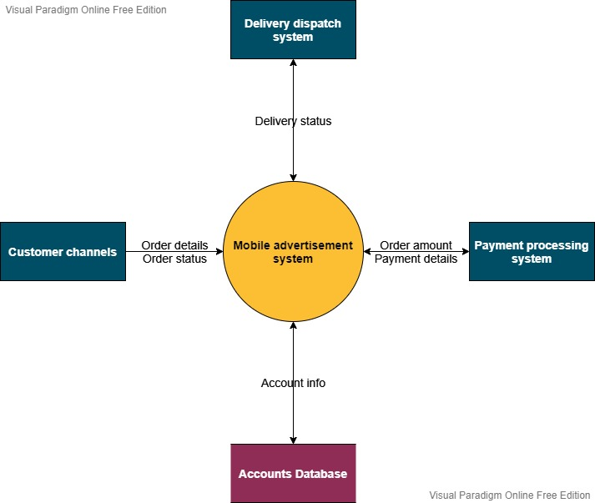

**USE CASES**

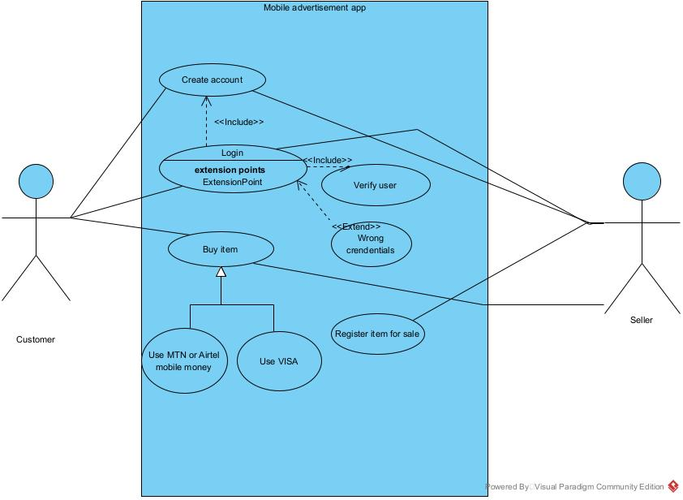

**ACTIVITITY DIAGRAM FOR BUYING ITEM**

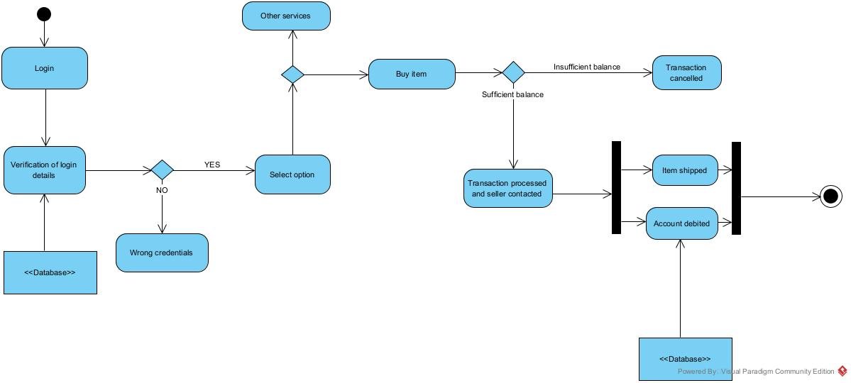

**SEQUENCE DIAGRAM FOR LOGIN**

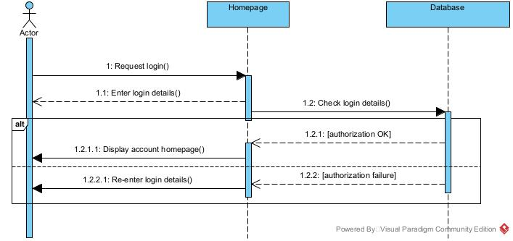

**SEQUENCE DIAGRAM FOR UPLOADING ITEM FOR SALE**

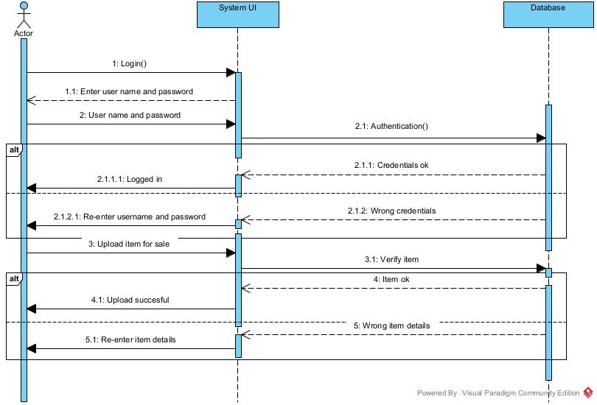

**SEQUENCE DIAGRAM FOR SEARCHING ITEM**

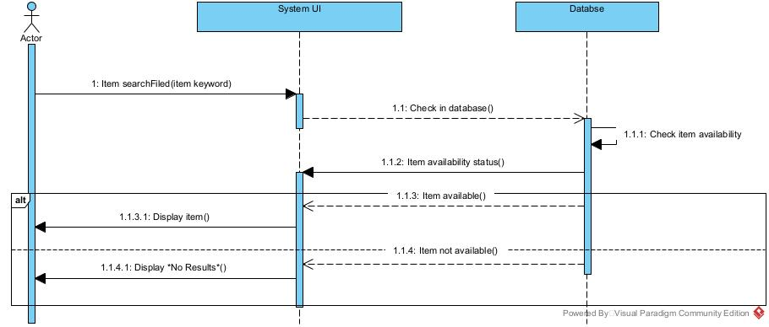

**SEQUENCE DIAGRAM FOR DELETING ITEM**

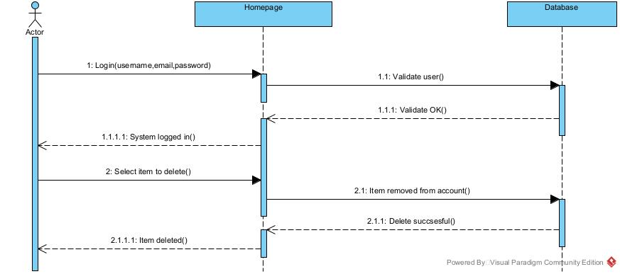

**SEQUENCE DIAGRAM FOR ADVERTSING**

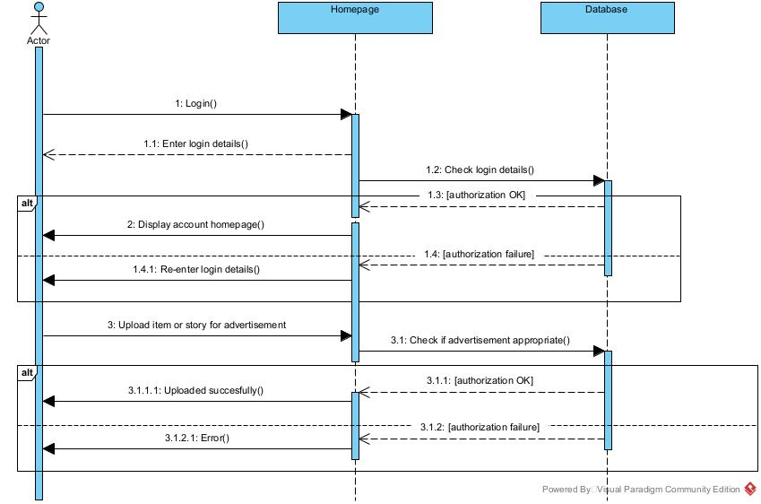

**SEQUENCE DIAGRAM FOR BUYING ITEM**

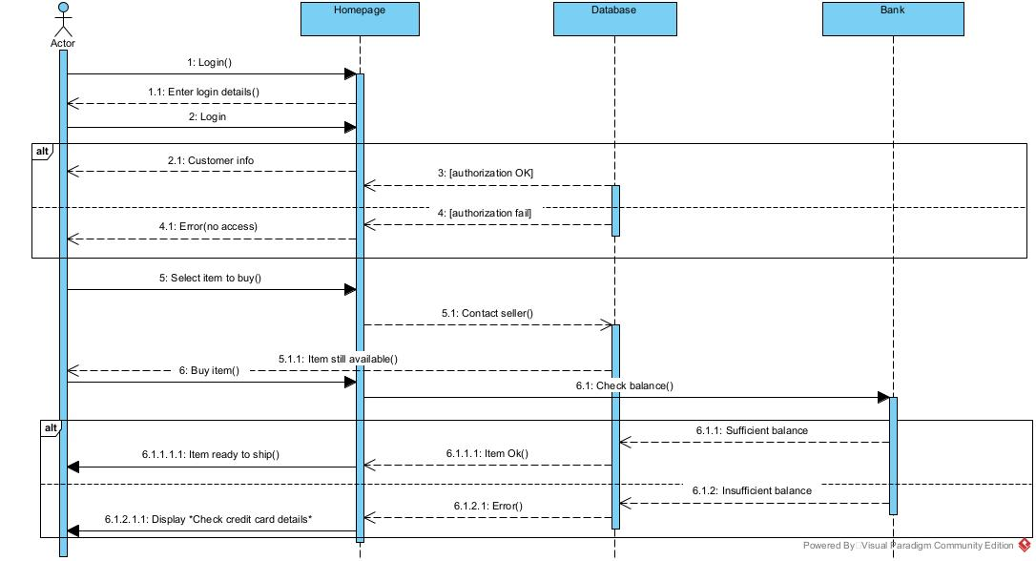

**STATE DIAGRAM**

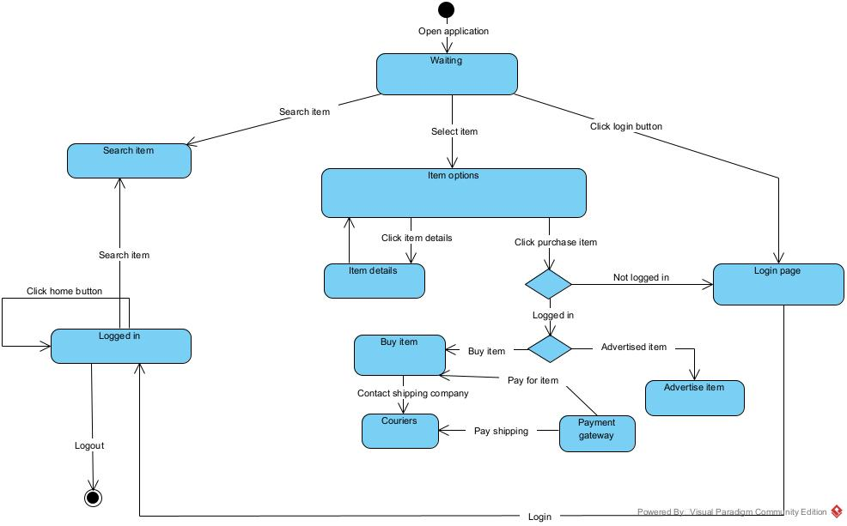

**CLASS DIAGRAM**

